Luke Schofield

NSCC  W0435794

Tech Services Project Plan & Progress

Contents

Activity List & Requirements Documentation 1

Activity Resources Requirements and Costs Estimates 1

Activity Duration Estimates 2

WBS 2

Progress Coverage 3

# Activity List & Requirements Documentation

This is a list of the major actives we had to do more information and details on these topics can be found in the WBS or the Microsoft Project Document.

1. Site Acquisition
2. Ticket Creation
3. Ad Creation
4. Collection of Computers
5. Running the Event

These Activities overlap with our requirements as well primarily the first three of needing a site, tickets and running an ad to get people to submit computers for repairs. But we have some additional requirements such as to clean the computers and to follow covid-19 protocols such as social distancing, wearing masks and sanitizing all PCs that we take in to be repaired.

# Activity Resources Requirements and Costs Estimates

- Cleaning gear & Wipes (5$)

- Masks / Gloves (15$)

- Anti-Static Straps (15$)

- Paper for tickets (3$)

- Lunch (30$)

* Students for repair
* Computer Repair Tools (Screw drivers)
* Anti-Static Straps
* Gloves, Covid-19 Medical Masks
* Monitors, Keyboards Mice (For testing)
* Cleaning Supplies
* Desks/Tables, Chairs
* Location to do the event
* Internet

The cost of the project has been almost nothing because we have these supplies on hand and could contribute them by simply brining stuff from our homes as needed.

# Activity Duration Estimates

* Making the Advertisement & Advertising the event October 14th
* Finding a location for the event October 30th
* Collecting necessary supplies November 1st
* Running the event November 2nd – December 30th (Includes remote repairs)

# WBS

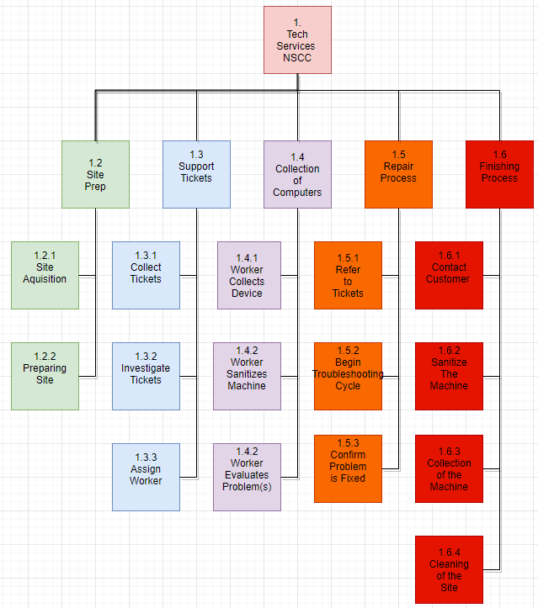

# Progress Coverage

**Tech Services Ticket**

-----------------------

Date Completed: 2020/10/10

Customer: Debbie

Problem: Computer needed a broken hard drive removed and a new hard drive installed with a fresh windows install.

Solution: Read problem.

Successful Completion? [ Yes ]

Technician: Luke Schofield

**Tech Services Ticket**

-----------------------

Date Completed: 2020/11/7

Customer: James

Problem: Needed a gaming computer built with the provided parts

Solution: Created a functional gaming pc

Successful Completion? [ Yes ]

Technician: Luke Schofield

**Tech Services Ticket**

-----------------------

Date Completed: 2020/10/28

Customer: Gladys

Problem: Laptop required new HDD and Operating System installed

Solution: Replaced HDD with new one provided by client, installed Windows 10

Successful Completion? [ Yes ]

Technician: Chris Cassidy

**Tech Services Ticket**

-----------------------

Date Completed: 2020/10/26

Customer: Bruce

Problem: Needed filed from old hard drive, but display on current machine was broken.

Solution: Hooked up hard-drive my my computer and backed them up, transferred them to my external SSD for easy transfer to customer.

Successful Completion? [ Yes ]

Technician: Thomas Phillips

**Tech Services Ticket**

-----------------------

Date Completed: 2020/10/24

Customer: Sylvie

Problem: Computer was running slow, bogged down with bloatware

Solution: Formatted computer and reinstalled fresh copy of Windows

Successful Completion? [ Yes ]

Technician: Chris Cassidy

**Tech Services Ticket**

-----------------------

Date Completed: 2020/10/20

Customer: Evan

Problem: Client wanted to build a budget gaming PC, and was looking for a list of compatible, affordable parts

Solution: A list of computer parts that matched the clients expectations was drafted, and the client was satisfied with the machine

Successful Completion? [ Yes ]

Technician: Chris Cassidy

**Tech Services Ticket**

-----------------------

Date Completed: 2020/10/1

Customer: Jennifer

Problem: Needed a new Wi-Fi router suitable for a family.

Solution: Purchased a new router (TP-Link AC4000) and setup multiple wireless networks on different channels & frequency's.

Successful Completion? [ Yes ]

Technician: Brayden Randall

**Tech Services Ticket**

-----------------------

Date Completed: 2020/11/1

Customer: Gerald

Problem: Computer is running slower than normal. Customer suspects that the computer is full of dust and want's a full cleaning.

Solution: Ran benchmarks on system first, disassembled whole system, Applied new thermal paste, and cleaned the whole system with an air compressor. Ran benchmarks again after cleaning to ensure that it made a difference.

Successful Completion? [YES]

Technician: Kyle Gloade

**Tech Services Ticket**

-----------------------

Date Completed:

Customer: Dylan S.

Problem: 2 old laptops from a family member were left behind with no indication of what the password could be.

Solution: Passwords for administrator accounts were reset with command prompt in troubleshoot bootup.

Successful Completion? [Yes]

Technician: Travis Smith

**Tech Services Ticket**

-----------------------

Date Completed: 2020-11-15

Customer: Dylan N.

Problem: Computer was blue screening during games.

Solution: After hardware swapping with different machines the memory was faulty and had been ordered by client and replaced by me.

Successful Completion? [Yes]

Technician: Travis Smith

**Tech Services Ticket**

-----------------------

Date Completed: 2020-11-12

Customer: Austin E.

Problem: Computer hardware was outdated and “sluggish” was interested in moving to Linux

Solution: Installed Ubuntu for client and software.

Successful Completion? [Yes]

Technician: Travis Smith